FA OF ICELAND CLUB LICENSING SYSTEM  TOOLKIT: TCP 13.5  Confirmation of no overdue payables | 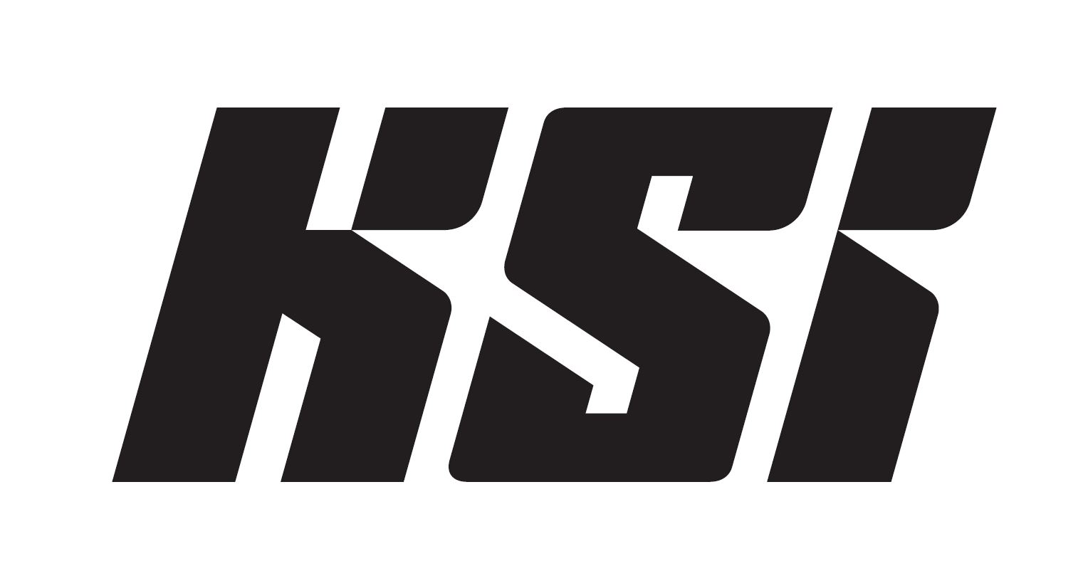

CONFIRMATION THAT CLUB (LICENSE APPLICANT) HAS NO OVERDUE PAYABLES TOWARDS EMPLOYEE (PLAYER, COACH, ETC.)

I, the undersigned, hereby confirm that the club listed below has no overdue payables towards me with regards to wages or salaries before March 1st 2023, which may fall due before April 1st.

Name of club:

Name of employee (in print letters):

I hereby confirm the above with my signature below.

Signature of player/coach:

Date:

